Linux task

- Create user with name Techie and provide sudo access to user.
Ans : useradd techie
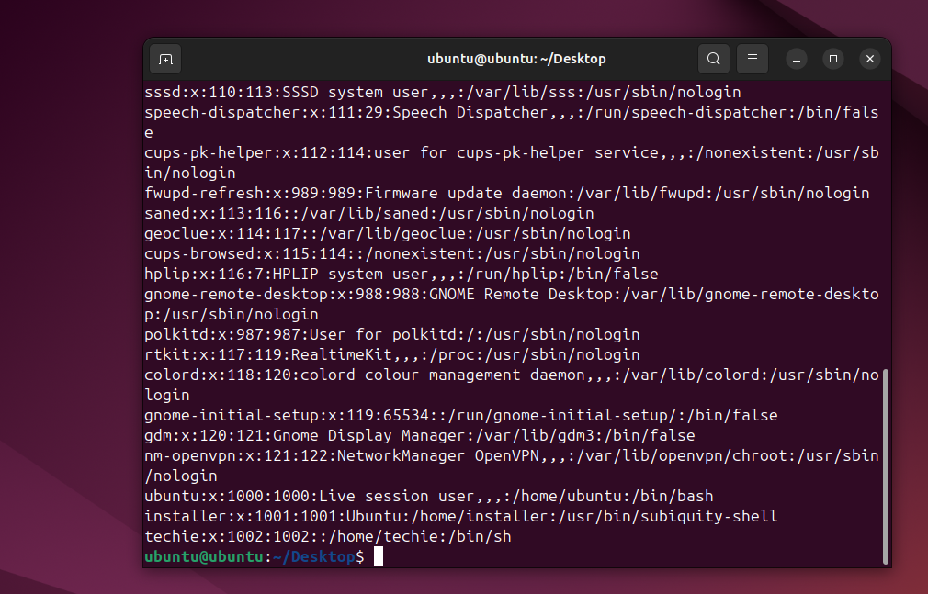
To able to provide access to user in sudo
Ans : entre the command vi /etc/sudoers and need to entre the user name and ALL=(ALL:ALL) ALL the save the file
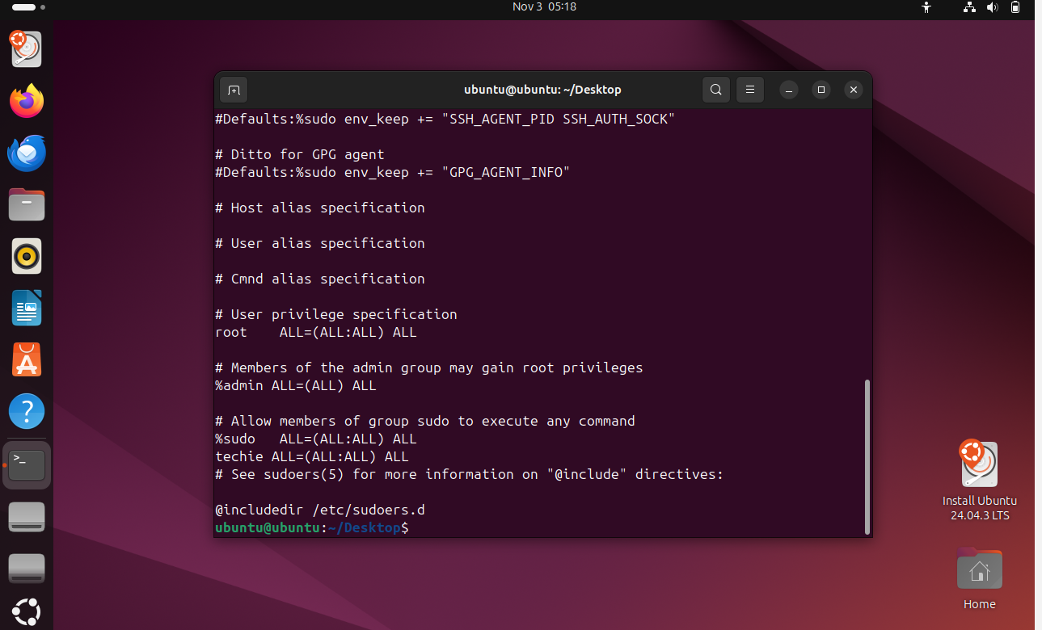

2 . Navigate to the home directory.
Ans : by using command cd ~ to go home directory
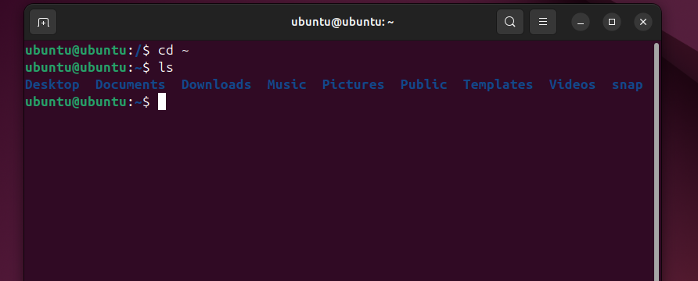

- Create a new directory.
Ans : by using the command mkdir directory name
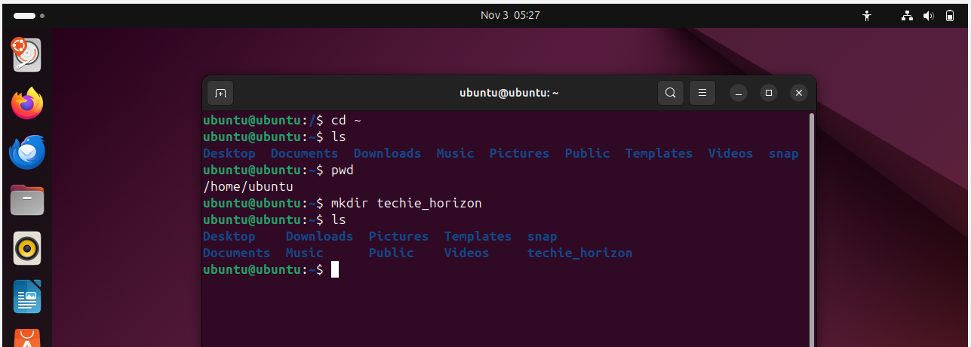

- List the contents of a directory
ans : using the command of ls


- Change the current directory
Ans : using command mv directory name /directory
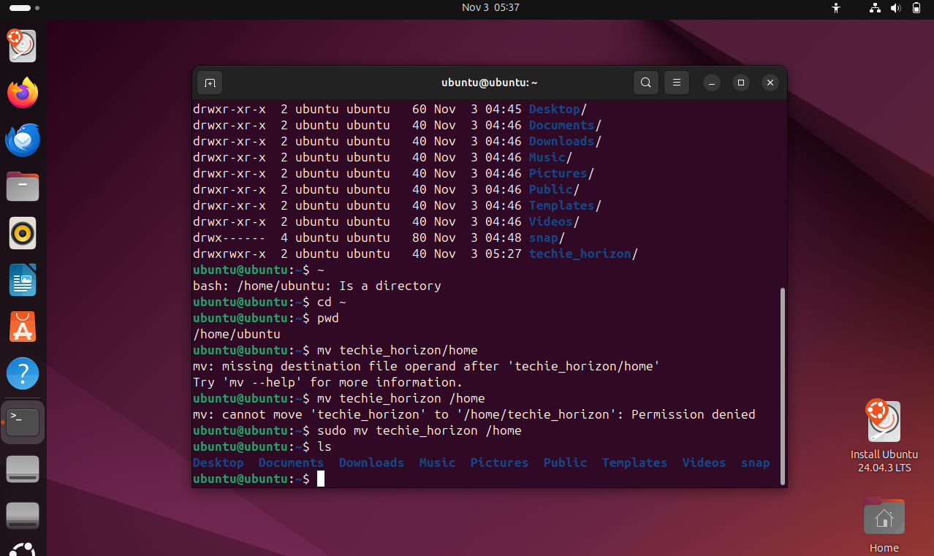

- Create a new empty file.
Ans . using command of mkdir and file name
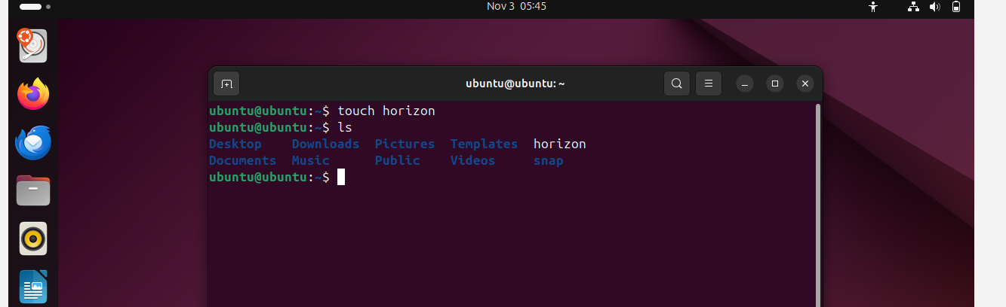

- View the contents of a file.
Ans . using cat file name to view file content 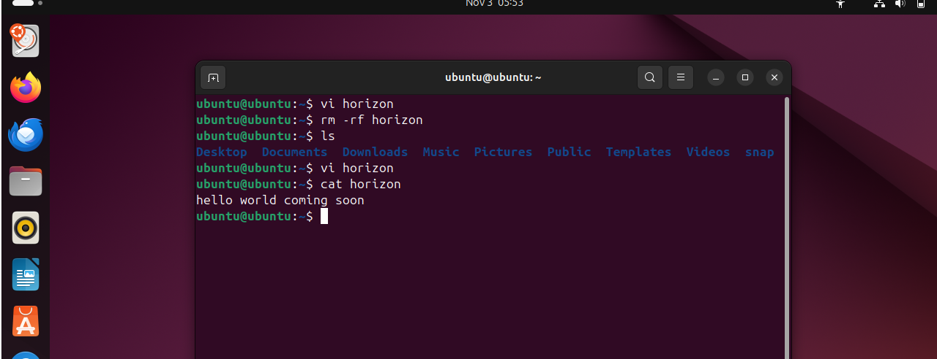

- Copy a file to another location.
Ans : using command cp file name directory
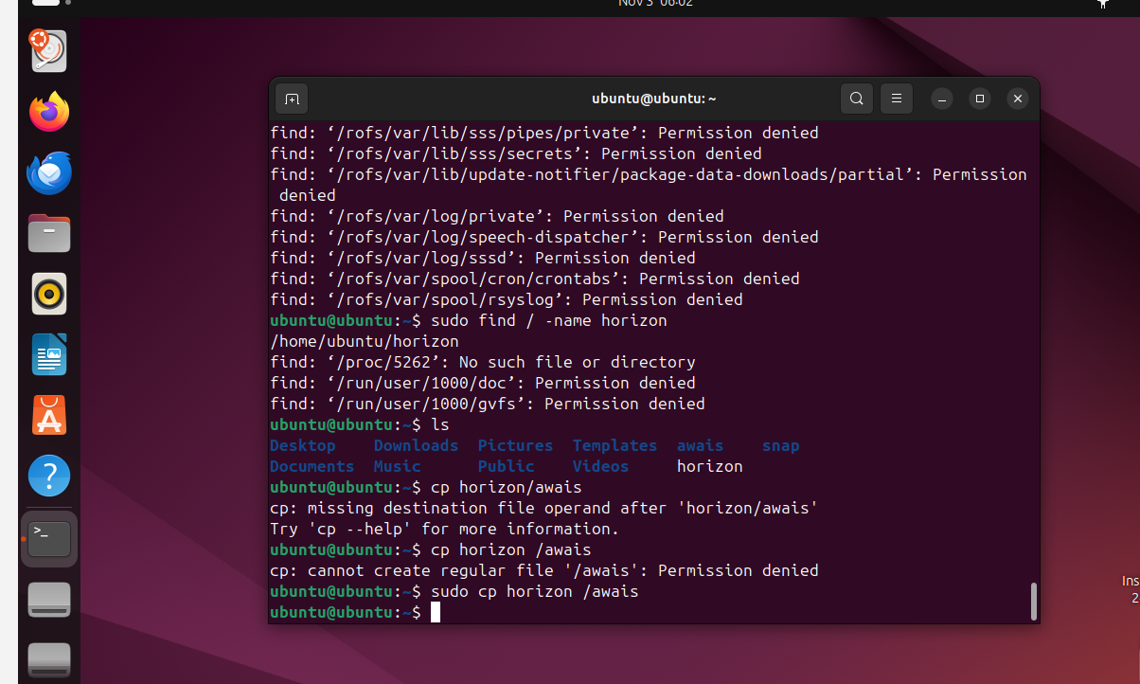

- Move a file to another location
Ans : by using command mv file name space directory name 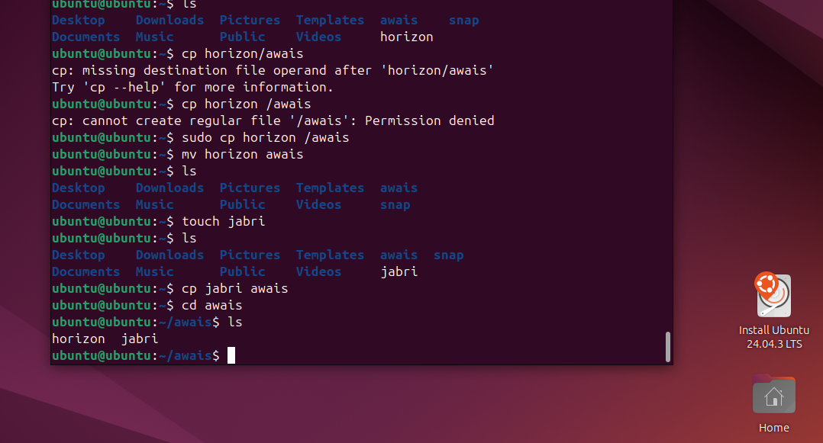

- Rename a file.
Ans: using mv old filename new filename
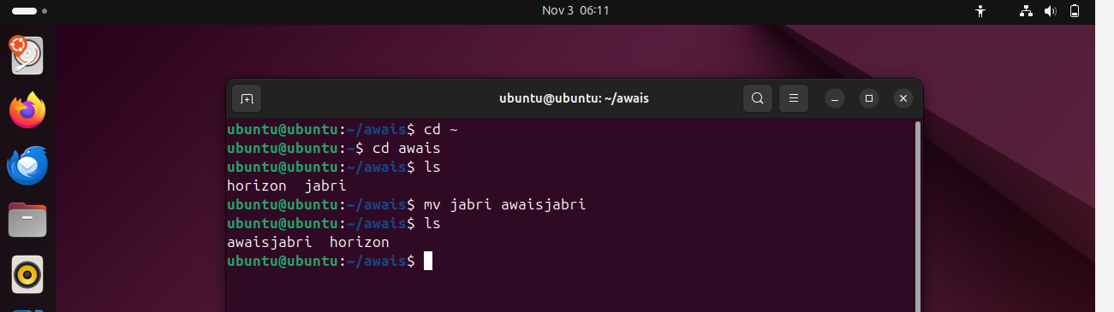

- Delete a file.
Ans : using command of rm -rf filename 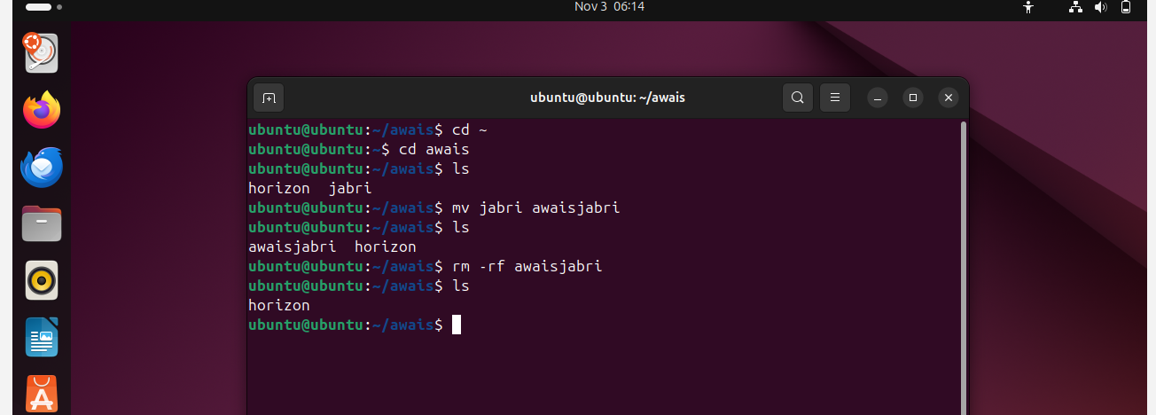
- Grant or revoke permissions on a file or directory.
Ans : using command of chmod permission file name
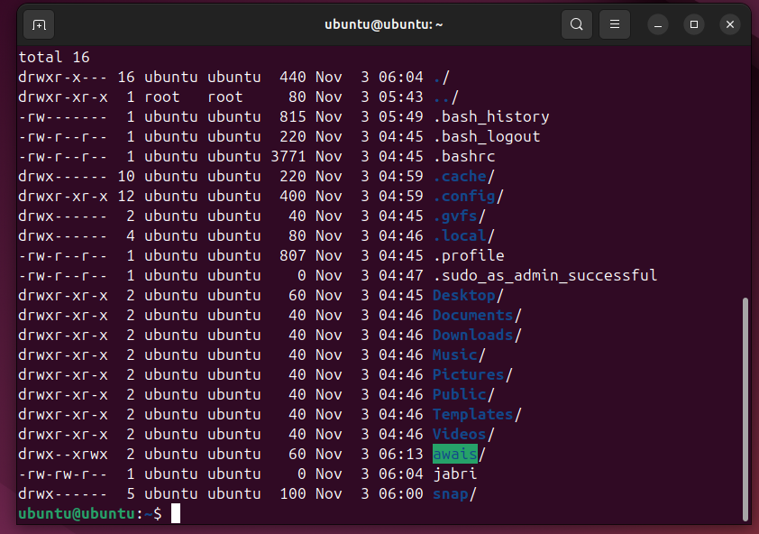

13.View the current date and time
Ans. By typing date
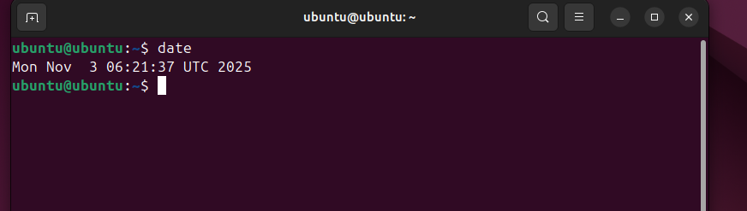

- Check the system uptime.
Ans: by using uptime 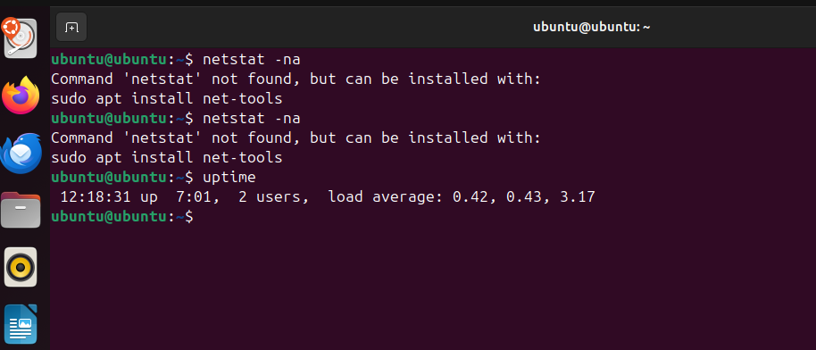

- View the running processes.
Ans : by using command of ps -ef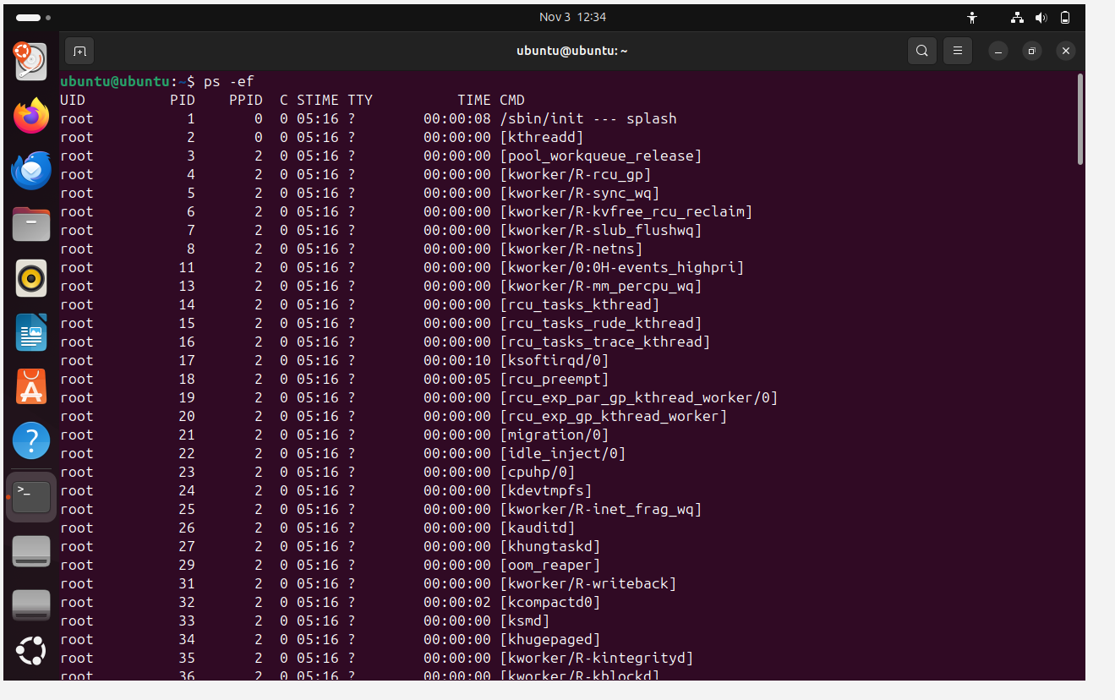

16. Kill a running process.
Ans . using command of kill -9 product id
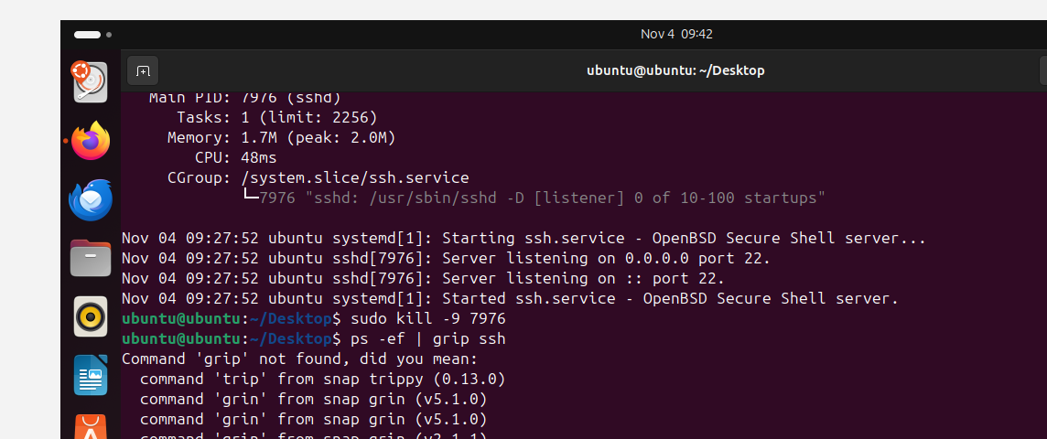

17.Install a package using the package manager (e.g., apt or yum).
Ans : to able to install the package need to use command of :apt install service name (nginx) -y
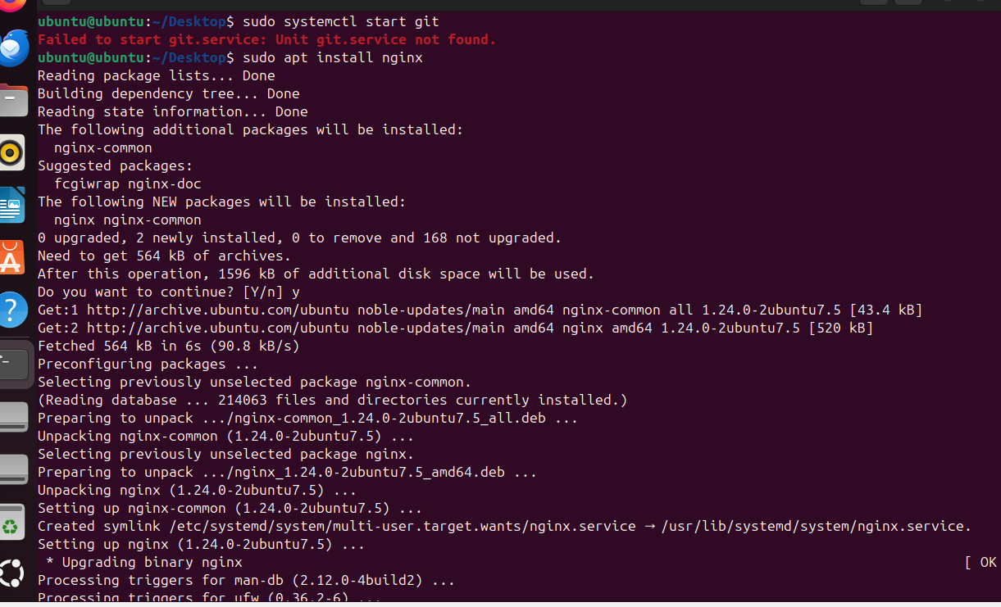

18. Update the system packages
Ans : using command of sudo apt update
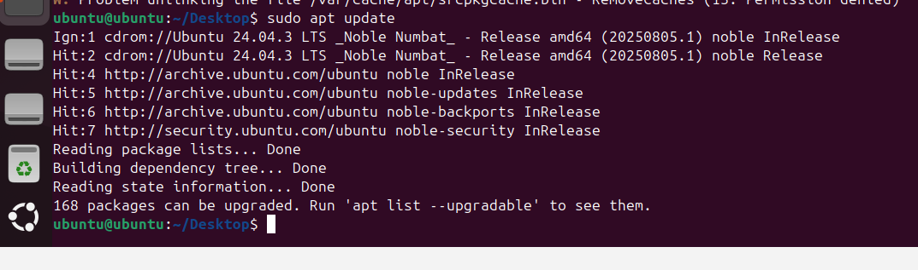

19. Create a symbolic link.
Ans : using command of ln -s filename filename _ link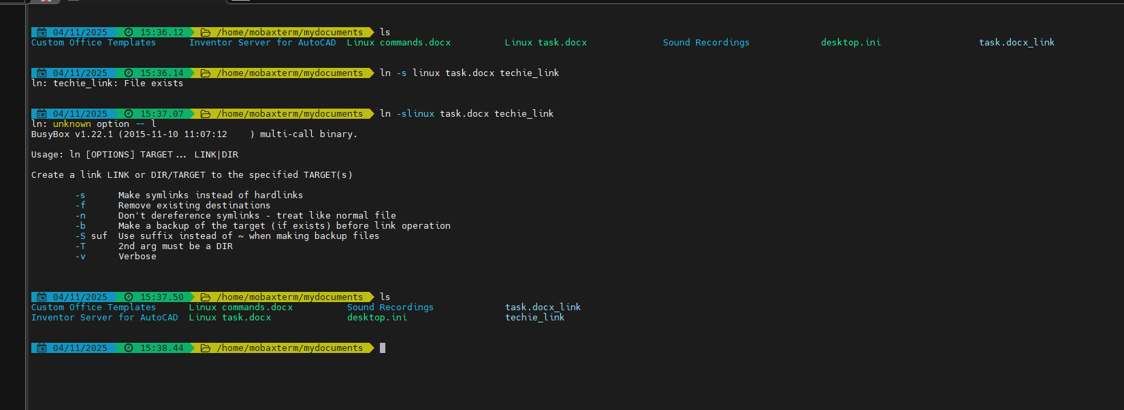

20. Search for files using the find command

Ans : using command of sudo find / -name filename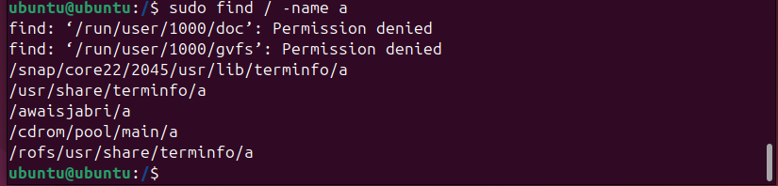

21. Compress and decompress files using tar.
Ans : to able to compress the files use the command tar cvf directory name bundle filename/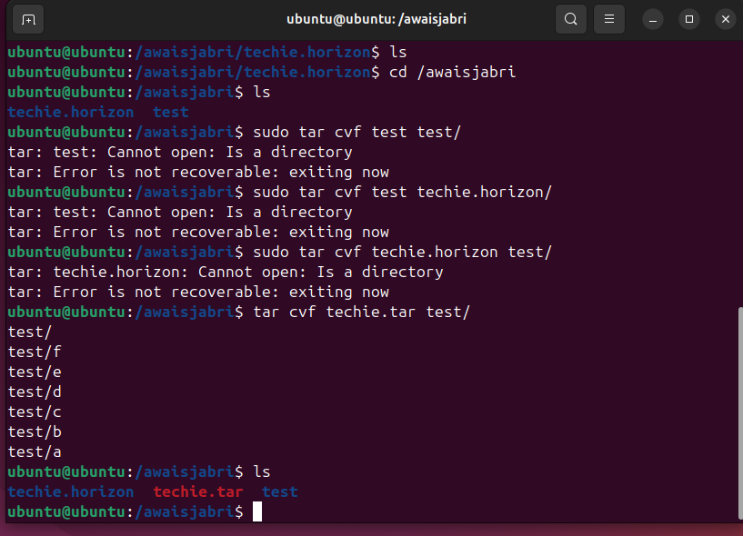

To able to decompress file use the command of
tar xvf 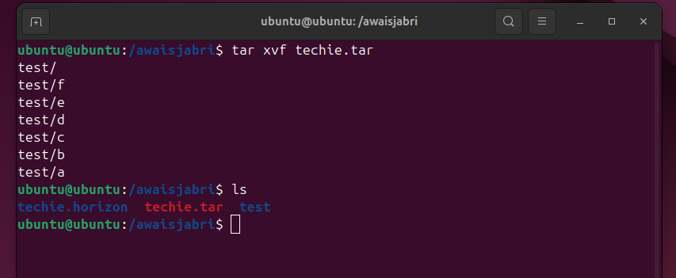

22. Monitor system resources with top or htop.
Ans : to able to view your system resources use command top 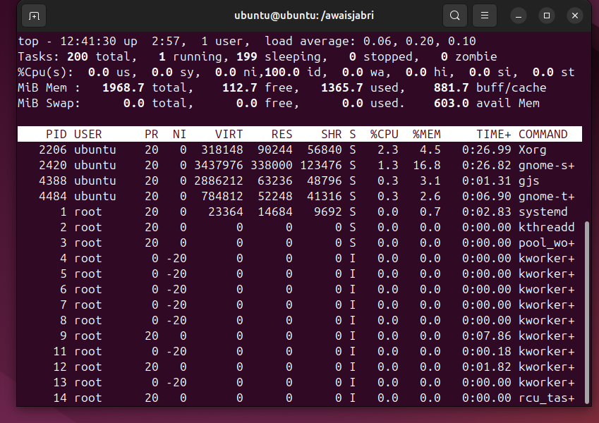
To able to under better as a human use command of htop (easier to read)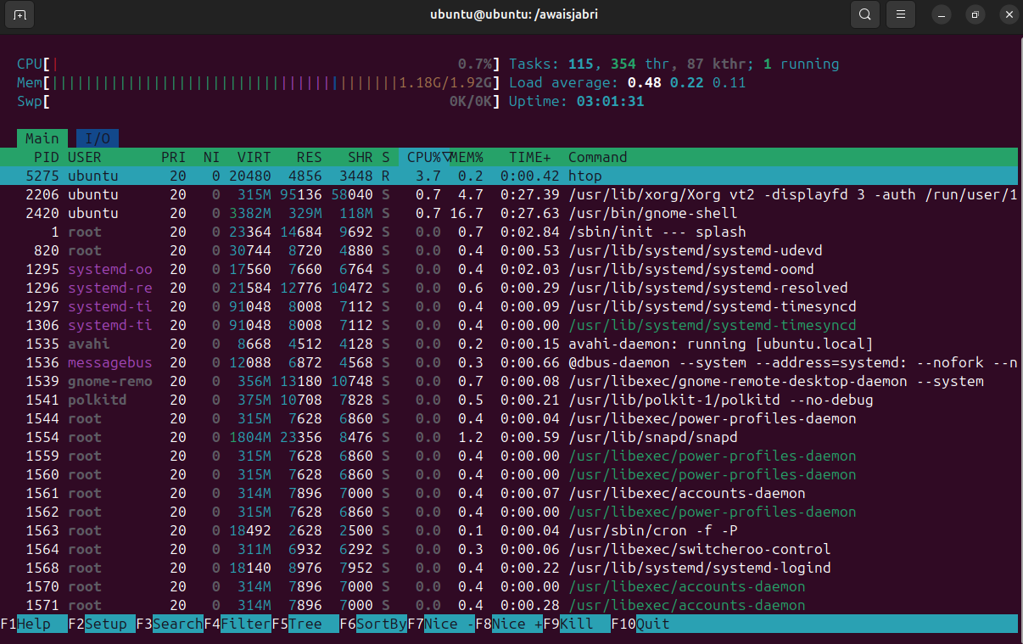

23. Create and manage user groups.
Ans: first need to create addgroup group name
then add user in that group by using command of
sudo usermod -aG group_name username
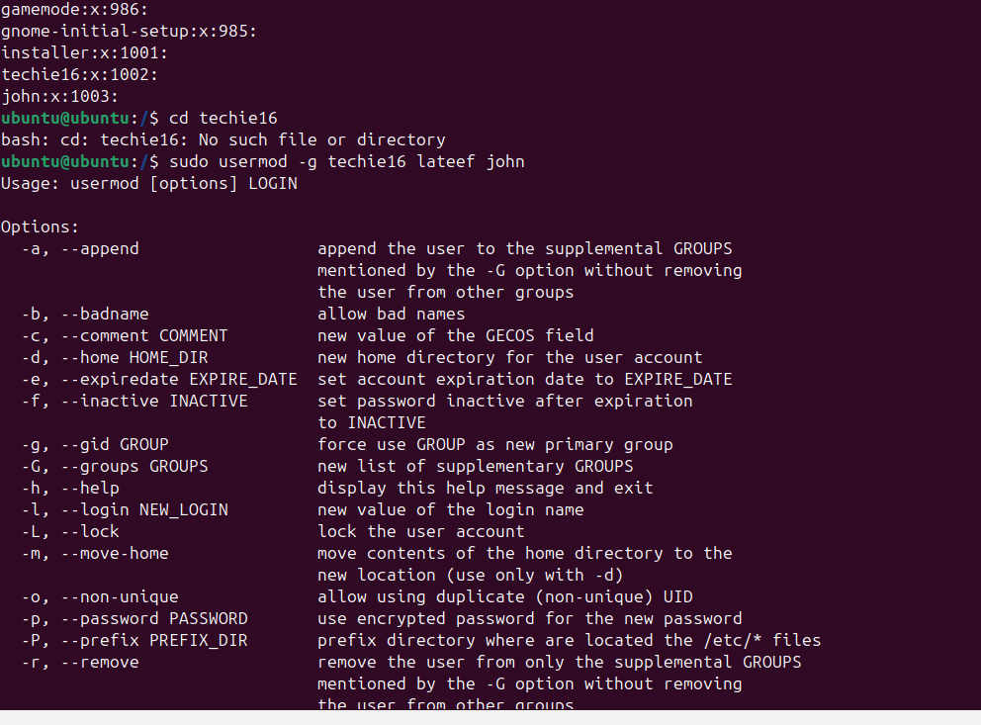

24. Set up SSH password less authentication.
Ans :

